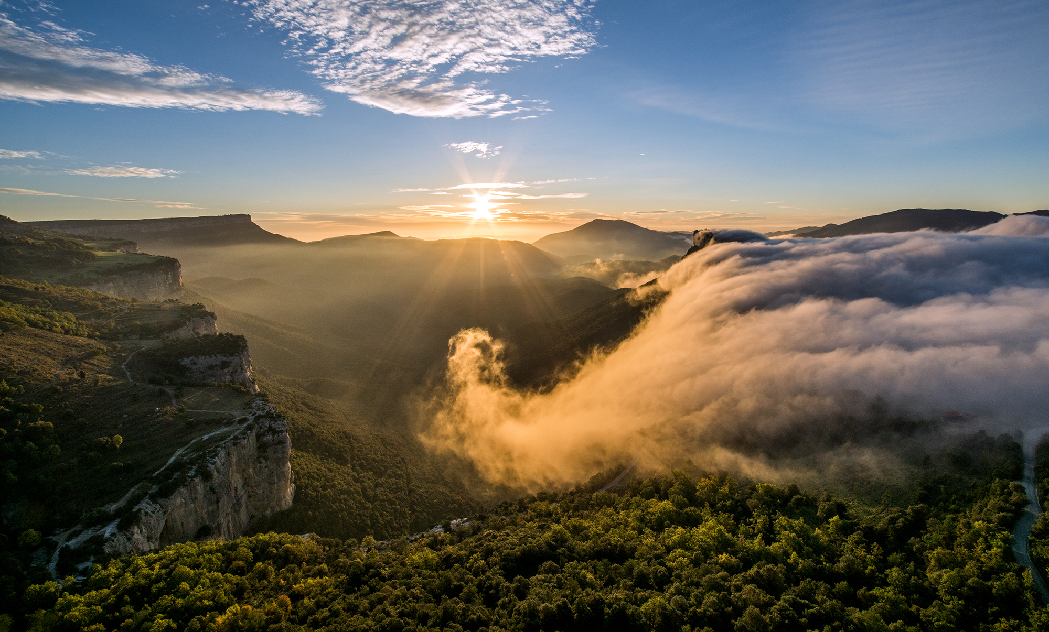
Best Tourism Villages
by UNWTO

Application Form
2023 Edition

Best
Tourism Villages
by UNWTO

Application Form
2023 Edition
March 2023

Application Form

Before you submit your application, we invite you to carefully read the following documents (available at http://www.unwto.org/tourism-villages/en/the-initiative/):
- Terms and Conditions
- Guidelines for Application
- Areas of Evaluation
- Candidacy Document
- General Presentation Template
IMPORTANT NOTES:
- All applications must be submitted online.
- All documents must be submitted in the format specified in the online application form and must not exceed the maximum length and/or size indicated. The title of each document should reflect the contents of the document.
- Make sure to have all mandatory documents ready for upload before submitting your application. Incomplete and/or late applications shall not be considered.
- Once an application is submitted, no changes can be made. The submitted application will be considered as the final version.
- Deadline for applications is 23 June 2023 (23:59 CEST).
- All fields marked with an asterisk (*) are mandatory.

Basic Information

- Name of the village* | Please make sure to write the exact name of the village. | Open-ended Question
- Country* |  | Drop-down Question
- Geographical Coordinates of the village*:  - Latitude  - Longitude | Please use the decimal degrees format | 2 open-ended questions
- Population of the village (number of inhabitants) * | Considering that a maximum of 15.000 inhabitants is an eligibility pre-requisite, please indicate the number of inhabitants | Open-ended Question
Submit/provide a supporting document of the population census for the village for the latest year available.* |  | File upload
Please provide the available data on the last 3 points on the population of the village (i.e. 3 last census) |  | 3 Open-ended Questions
- Extent of the village’s territory (in square km) |  | Open-ended Question
  - Contact information for representative in the village.
The contact provided will be the representative for all communications with UNWTO.
- Title (Mr/Ms/Other)* |  | Field Questions
    - Family Name*
    - First Name*
    - Institution*
    - Position*
    - Street Address and Number*
    - State/Province*
    - Postal/Zip Code*
    - Area Code + Telephone Number*
    - E-mail Address*
  - Contact information for the responsible for the application at the UNWTO Member State
The responsible for the application of the village will be the representative of the UNWTO Member State. This person will be responsible for the communication and coordination of all issues related to the candidacy.
- Title (Mr/Ms/Other)* |  | Field Questions
    - Family Name*
    - First Name*
    - Institution*
    - Position*
    - Street Address and Number*
    - State/Province
    - Postal/Zip Code
    - Area Code + Telephone Number*
    - E-mail Address*

- Key Tourism Data

Visitors
If available, we kindly ask you to provide the following for the last 4 years or the ones available in any of the years from that period.
Data | 2019 | 2020 | 2021 | 2022
Total number of overnight visitors (total tourists)*
Total number of international overnight visitors (international tourists)
Total number of domestic overnight visitors (domestic tourists)
Total number of same-day visitors (excursionists)*

If available, we kindly ask you to provide the following for 2022 or the last year available.
Average visitor expenditure (per person) in local currency:

- Please specify the currency Drop down
- Please specify the amount Open field question (numbers only)
- Please specify the reference year Open field question (numbers only)

Main origin of visitors:

Please use boxes below to select top 3 main visitor's countries of origin. If domestic visitors are part of the main origins, please include.

- Select country. Drop down question
- Select country. Drop down question
- Select country. Drop down question

Tourism products and tourism related businesses

Data | Number | Year of reference
Total number of tourism businesses in the village
Total number of rooms available in the village (accommodation capacity)*

Main tourism products/experiences:

Please, use the box below to list the main types of tourism products offered by the village:

- Open text. Open field question

Employment

Data | Number | Year of reference
Total number of employed people in the village
Total number of employed people in tourism related jobs in the village
Total number of employed women in tourism related jobs in the village

- Motivation and Areas of Evaluation

- Please upload a short video either in English or Spanish telling us why the village should become a Best Tourism Village by UNWTO. *  Format and limit specified: mp4 format, 2min max., 30MB max. | File upload field
- Please upload a general presentation following the structure provided in the template “General Presentation”. *  Format and limit specified: PDF format, 12 slides max, 20MB max. | File upload field
- Please upload the document “Candidacy Document” completed. *  Format and limit specified: PDF format, limit specified in the number of words allowed per question, 20MB max. | File upload field

Supporting Visual Files

- Please upload relevant supporting visual files that are relevant to showcase the village resources and initiatives.*  Format and limit specified:  Images: jpg. Up to 10 images. 20MB per file max.  Videos: mp4. Up to 3 videos. 30MB per file max. | File upload field
- Please provide up to three YouTube links (or to other similar video sharing platforms (i.e.: vimeo, Tencent, iQiyi, etc.) of promotional videos of the village (if any). | 3 link fields

Compliance Framework

How did you learn about the Best Tourism Villages by UNWTO initiative? * | - UNWTO website  - Social Media  - Direct Communication from UNWTO  - Press  - Event  - Recommendation from colleague or partner  - Other | Multiple Choice Question

1. I am/We are aware and accept the Statutes of UNWTO and the Global Code of Ethics for Tourism * | ☐  YES
2. I am/We are aware and accept to comply with the Terms and Conditions of ‘Best Tourism Villages by UNWTO’ initiative. Accordingly, I/we recognize that UNWTO reserves the right to suspend or exclude a village from ‘Best Tourism Villages by UNWTO’ Network at any time in case of breach of these Terms and Conditions, for not meeting the requirements for joining the initiative for any other reason duly justified.* | ☐  YES
3. I/We understand and accept that the village, once officially a member of ‘Best Tourism Villages by UNWTO’ Network may mention its membership as such. Only villages recognised as Best Tourism Villages by UNWTO can use the initiative’s logo according to the Terms and Conditions and to the Guidelines for the use of the logo. Any use of UNWTO’s signs (name, emblem, flag or acronym) shall be subject to prior written authorization by UNWTO and in full compliance with the terms and conditions in accordance with UNWTO Terms of Use.* | ☐  YES
4. By becoming a Member of ‘Best Tourism Villages by UNWTO’ Network, the village accepts to comply with the terms and conditions established by the UNWTO, in particular on the use of UNWTO signs and the prohibition to be involved in any activity that could be opposed to the objectives or principles of the UNWTO or the UN or that could adversely reflect upon the UNWTO.* | ☐  YES
UNDERTAKING
I, hereby, declare that all the information provided above is true and correct to the best of my knowledge and that I have read, understood and accepted the Terms and Conditions and agree to all of the terms therein. Should I fail to adhere to the conditions set out by said Terms and Conditions, I understand that the UNWTO reserves the right to dismiss my application or remove the recognition to the village.* | ☐  YES
DATA PROTECTION
1. By submitting their application, participants acknowledge that referenced projects and visual materials are their own originals and/or they own the necessary right to ownership or property rights thereover. Participants shall duly credit third party copyrights and license to use them when applicable or if requested by the Secretariat at any time. Participants agree to hold harmless UNWTO from any and all losses, claims, damages, expenses or liabilities which could arise in relation to intellectual property rights or personal data of third parties in relation to the applications submitted and visual materials uploaded in the application. UNWTO shall not claim any property on the initiatives submitted or any other industrial or intellectual property contained in their application. Participants do not cede UNWTO industrial or intellectual property rights arising as a result of their applications.* | ☐  YES
2. By submitting their application, participants expressly grant their consent to the use of the name or their village and initiatives in connection with the ‘Best Tourism Villages by UNWTO’ initiative and the recording and maintenance of related files. Participants may exercise their rights to access, modify, cancel and oppose the processing of their personal details by sending an email to besttourismvillages@unwto.org indicating which right they wish to exercise and attaching a copy of their passport, national ID card or equivalent documentation.* | ☐  YES
☐ I agree*

Name**
Organization *
Position*
Country*
Date*

**The person submitting the application is the responsible for the application at the UNWTO Member State (same person indicated in field 1.7.).
March 2023

With the vision of making tourism a positive force for transformation, rural development and community wellbeing, the Best Tourism Villages by UNWTO initiative seeks to advance the role of tourism in valuing and safeguarding rural villages along with their associated landscapes, knowledge systems, biological and cultural diversity, local values and activities.

The World Tourism Organization (UNWTO), a United Nations specialized agency, is the leading international organization with the decisive and central role in promoting the development of responsible, sustainable and universally accessible tourism. It serves as a global forum for tourism policy issues and a practical source of tourism knowhow. Its membership includes 160 countries, 6 territories, 2 permanent observers and over 500 Affiliate Members.

World Tourism Organization (2022) UNWTO Basic Documents, Volume I ‐ Statutes, Rules of Procedure, Agreements, seventh edition, UNWTO, Madrid. https://doi.org/10.18111/9789284423781
https://webunwto.s3.eu-west-1.amazonaws.com/imported_images/37802/gcetbrochureglobalcodeen.pdf
A/RES/601(XIX) available at https://www.e-unwto.org/doi/pdf/10.18111/unwtogad.2011.1.q143011gl1856q48

